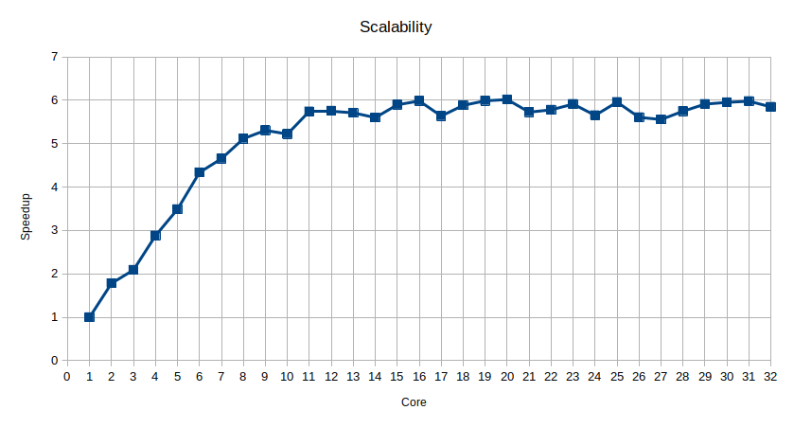
To measure data we create a timer class that measures nano time on start and stop timer on stop.
We put start on task creation and stop when all threads have finished to calculate.
From the chart we can see a linear behavior until 8 core then the speedup stays in the rage of 5 and 6. this happens because of the OS’ threads that influence the execution, context-switches.
Core | Time (ms) | SpeedUp
1 | 10466.1864 | 1
2 | 5869.898497 | 1.78302681134079
3 | 5004.013306 | 2.09155846717087
4 | 3631.686736 | 2.8819078188246
5 | 2999.087964 | 3.48978973795782
6 | 2413.026399 | 4.33736920753845
7 | 2248.453444 | 4.65483794113195
8 | 2045.540507 | 5.11658721212505
9 | 1971.771587 | 5.30801157142346
10 | 2004.175853 | 5.2221896518379
11 | 1823.090811 | 5.74090239325988
12 | 1817.894077 | 5.75731365892997
13 | 1832.405059 | 5.71172096944096
14 | 1868.472544 | 5.6014665206662
15 | 1774.885377 | 5.89682383754295
16 | 1748.950472 | 5.98426688894824
17 | 1856.292649 | 5.63822003262159
18 | 1778.858391 | 5.88365350100541
19 | 1747.762049 | 5.98833600145302
20 | 1739.422213 | 6.01704768501769
21 | 1827.430399 | 5.72726950680435
22 | 1810.792149 | 5.779893846889
23 | 1769.930132 | 5.91333308065293
24 | 1851.421842 | 5.65305332505632
25 | 1756.329827 | 5.95912353084464
26 | 1866.52505 | 5.6073109760836
27 | 1883.248561 | 5.55751726922466
28 | 1820.726973 | 5.74835576953909
29 | 1770.221386 | 5.91236016171369
30 | 1758.501055 | 5.95176577815587
31 | 1750.447901 | 5.97914761931552
32 | 1789.854134 | 5.84750801821485

